Lewa Write Up

Cem Mutlu, Max Noteboom and Andy Craig

1. What possible impact will this project have on students in Kenya?  
2. How can technology help Lewa and its surrounding communities?  
3. How can technology promote conservation?  
4. What impact did this project have on you and your understanding of conservation?

1. Kenya is a generally poor and a third world country. Within Kenya there is a wildlife conservancy called Lewa. Even with this poverty Lewa has some majestic animals that are going extinct. Students in Lewa will definitely enjoy the games that are made but this will also broaden their horizons and expand their knowledge outside of basic school. This will teach them about conservation of animals and the importance of the protection of animals that are in danger. 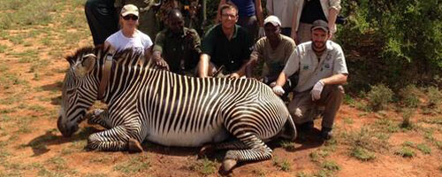
2. This project will also show them more about the things that computers can achieve and maybe inspire some or give them more opportunities later in life. Just implementing computers and OLPC’s to kids at an early age really can help the community by raising the level of education and the amount of people going onto higher education so that they can get better jobs so they will not have to resort to poaching to feed their families. This will gradually increase the wealth of the towns with each generation having more opportunities.

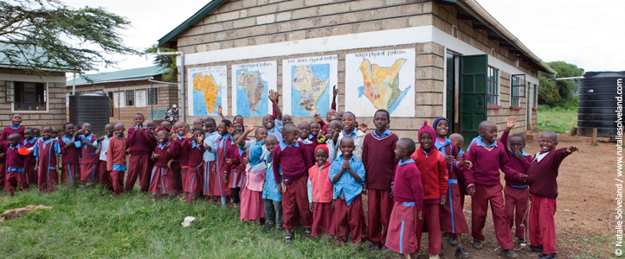

1. Simply showing the students that poaching is bad and teaching them about the level of importance of these conservatories at a young age helps cement the idea of conservation. Young children are the most impressionable, The Lewa foundation also does just that with funding for over 15 schools and 234 kids providing them with funding and grants for secondary school.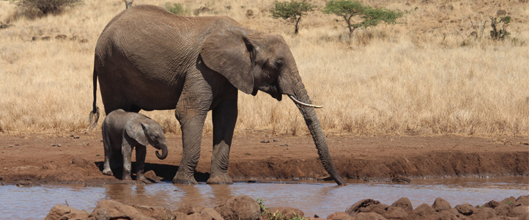
2. Doing this project helped me learn about the actual urgentness and the massive scope of this poaching. That the population has gone from millions to just thousands and almost extinct with some species. I have also learned that Lewa has been awarded a silver award for helping fund schools. They also provide healthcare for these communities.

